How to create a windows password reset CD
Article Source:
http://recoverlostpassword.com/article/create-windows-password-reset-cd.html
There is nothing worse than forgetting a windows account password, this period you will lose access to your computer and your data could be ruined completely if you cannot solve your problem all the time.
To avoid such a hot potato, it is necessary for computer users to create a windows password reset disk while set a password for a windows account. Then anytime you forgot your computer password, you can use this disk to reset a new password.
Create Windows Password Reset disk through Windows Built-in Features
Requirements：To complete creating windows password reset disk, you need to prepare removable media such as USB flash drive or a blank, formatted floppy disk.

Note: it doesn't support to create windows password reset disk with a CD/DVD or external hard drive, so if you don’t have a USB flash drive or a floppy disk and only have a CD, then you have to create a Windows Password Reset CD with 3rd party utility.
To create a Windows Password reset disk, follow these steps, here take Windows XP as example.
1. Open Control Panel by clicking the start button, and then click the User Accounts link.
2. In the User Accounts pane, click the account that you want to create a password reset disk for, and then click Prevent a forgotten password.
3. When the Forgotten Password Wizard appears, follow the instruction to create a password reset disk. When complete the progress, remove the password reset disk and store it in a safe place.
If you put off creating a Windows password reset disk and now forgot the windows password, it is the time to kick yourself.
Luckily, there are so many online password recovery services out there that can help, such as Login Recovery and Fast Crack. They are easy to use but may make you wait two or more day to regain your lost or forgotten password. Instead, the following steps will show you how to reset Windows password rely on windows password reset software in minutes.
Create Windows Password Reset CD through windows password reset Software
Requirements：To complete creating windows password reset CD, you need to prepare a blank bootable CD/DVD and CD-ROM drive
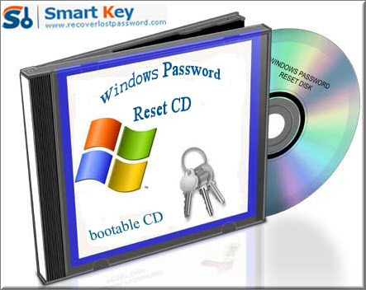
To create a Windows Password Reset CD, follow these steps, here take SmartKey Windows Password Recovery Standard for your reference:
1. Download Windows Password Recovery Standard form any available computer which can link to Internet, install the software on that computer.
2. Run the software and insert a CD/DVD in computer.
3. Burn your Windows password reset CD.
4. Put in your newly created Windows password reset CD to a locked computer. Follow the wizard to remove or reset forgotten windows password.
By the way, if you have got a USB flash drive and don’t have a CD/DVD, Windows Password Recovery Professional/Enterprise can be your best choice to create a Windows Password Reset USB flash drive.
Contact:
Official Website: http://recoverlostpassword.com/products/windowspasswordrecoery.html
Email: support@recoverlostpassword.com

